Jensen's inequality

Property

Continuous Function with real numbers

Convex Function

Subject to:

$$sigma\left(p_{i},i=1,i=n\right)$$ == $$1$$

For continuous convex functions $$f:R→R$$.

Concave Function

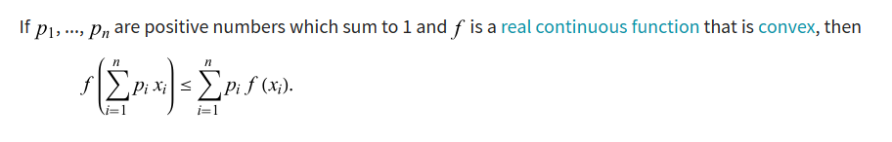

For continuous concave functions, the inequality reverses.

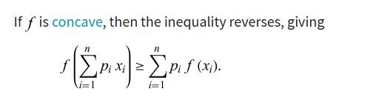

Continuous Function to Random variable

For any random variable X and f is a convex function, one will apply that:

$$f\left(E\left[X\right]\right)≤E\left[f\left(X\right)\right]$$

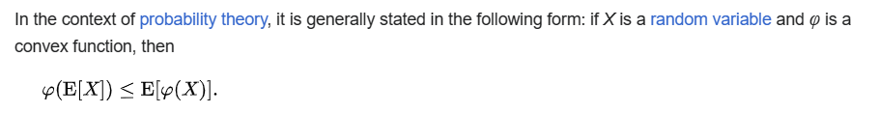

Proof:

See Wiki.

Special case

natural logarithm

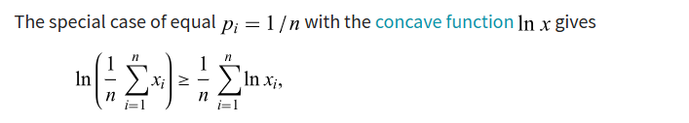

AM-GM

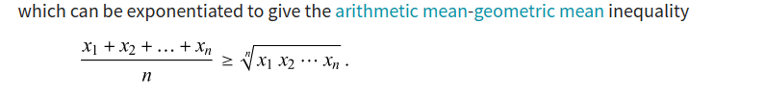



Proof

natural logarithm

Suppose $$p_{i}=\frac{1}{n},i=\left\{1,2,…,n\right\}$$

Since $$f\left(x\right)$$ = $$\ln\left(x\right)$$ is a concave function, we have that

$$\ln\left(sigma\left(\frac{1}{n}⋅x_{i},i=1,i=n\right)\right)$$ $$≥$$ $$sigma\left(\frac{1}{n}⋅\ln{x_{i}},i=1,i=n\right)$$

=> $$\frac{1}{n}\ln\left(sigma x_{i},i=1,i=n\right)$$ $$≥$$ $$\frac{1}{n}⋅sigma\left(\ln{x_{i}},i=1,i=n\right)$$

AM-GM

Continue the previous proof of property, we can imply that

=> $$e^{\frac{1}{n}\ln\left(sigma x_{i},i=1,i=n\right)}$$ $$≥$$ $$e^{\frac{1}{n}\left(sigma \ln{x_{i}},i=1,i=n\right)}$$

=> $$\frac{1}{n}\ln{s}igma\left(x_{i},i=1,i=n\right)$$

$$≥$$ $$e^{\frac{1}{n}sigma\left(\ln{x_{i}},i=1,i=n\right)}$$

= $${\left(e^{sigma\left(\ln{x_{i}},i=1,i=n\right)}\right)}^{\frac{1}{n}}$$

= $${\left(product\left(e^{\ln{x_{i}}},i=1,i=n\right)\right)}^{\frac{1}{n}}$$

= $${\left(product\left(x_{i},i=1,i=n\right)\right)}^{\frac{1}{n}}$$

Hence proved.

Graph

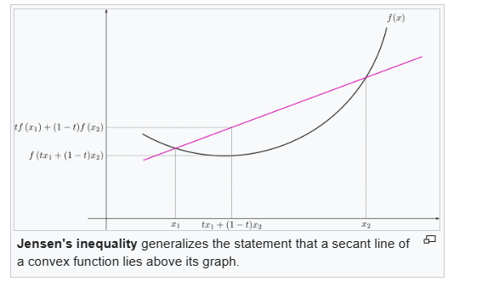

Ref

[Jensen's inequality - Wikipedia](https://en.wikipedia.org/wiki/Jensen%27s_inequality)

[Jensen's Inequality -- from Wolfram MathWorld](https://mathworld.wolfram.com/JensensInequality.html)